We Don't Talk Anymore
作詞：Selena Gomez / Jacob Kasher Hindlin / Charlie Puth 作曲：Selena Gomez /


<iframe width="560" height="315" src="https://www.youtube.com/embed/i2Z4JaFnMjU?si=dN-k4NbcFTQ2z-4v" title="YouTube video player" frameborder="0" allow="accelerometer; autoplay; clipboard-write; encrypted-media; gyroscope; picture-in-picture; web-share" referrerpolicy="strict-origin-when-cross-origin" allowfullscreen></iframe>We don't talk anymore Like we used to do
We don't love anymore What was all of it for?
Oh, we don't talk anymore Like we used to do
I just heard you found the one you've been looking
You've been looking for
I wish I would have known that wasn't me

243新北市泰山區貴子里致遠新村55之1號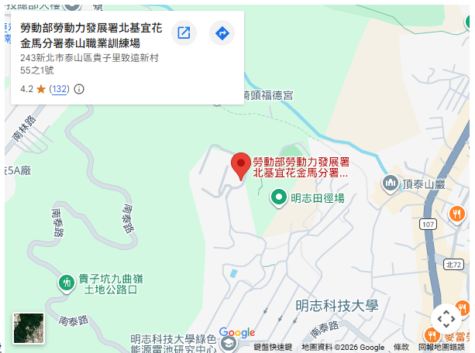
<iframe src="https://www.google.com/maps/embed?pb=!1m18!1m12!1m3!1d3614.7036493264513!2d121.41951560000001!3d25.044129299999998!2m3!1f0!2f0!3f0!3m2!1i1024!2i768!4f13.1!3m3!1m2!1s0x3442a7bec9ad74b1%3A0xa639904a89f26435!2z5Yue5YuV6YOo5Yue5YuV5Yqb55m85bGV572y5YyX5Z-65a6c6Iqx6YeR6aas5YiG572y5rOw5bGx6IG35qWt6KiT57e05aC0!5e0!3m2!1szh-TW!2stw!4v1776238104318!5m2!1szh-TW!2stw" width="600" height="450" style="border:0;" allowfullscreen="" loading="lazy" referrerpolicy="no-referrer-when-downgrade"></iframe>
<!DOCTYPE html>
<html>
<style>
table, th, td {
border:1px solid black;
}
</style>
<body>

<h2>TD elements define table cells</h2>

<table style="width:100%">
<tr>
<td>Emil</td>
<td>Tobias</td>
<td>Linus</td>
</tr>
</table>

<p>To understand the example better, we have added borders to the table.</p>

</body>
</html>

